<!--This file created 2:29 PM 10/29/97 by Claris Home Page version 2.0-->2.3 Project
Numerical -Limit Investigations

Figure 2.2.23 in the text shows a steadily rising graph  that passes through the point 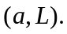 Given a single numerical value 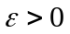, we can illustrate the limit 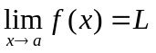 by solving the equations 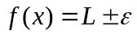 graphically or numerically for the indicated values 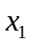 to the left of a such that 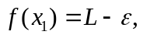 and 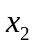 to the right of a such that 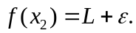 If 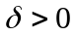 is chosen smaller than either of the two indicated distances 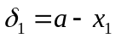 and 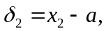 then the figure suggests that

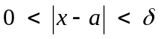 implies 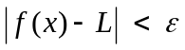. (1)

You should understand that an actual proof that must show that, given any whatsoever, there exists a that works for this — meaning that the implication in (1) holds.

Doing it for a single value of does not constitute a proof, but doing it for several successively smaller values of can be instructive and perhaps convincing. Suppose, for instance that

In the sections below we illustrate the use of a calculator or computer algebra system to solve the equations 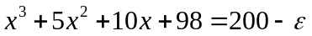 and 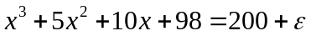 numerically for the solutions x₁ and x₂ near 3. With 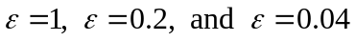 you yourself should complete the following table of results:

 | x₁ | x₂ | 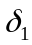 | 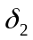
1 | 2.98503 | 3.01488 | 0.01497 | 0.01488 | 0.01
0.2 | 2.99701 | 3.00298 | 0.00299 | 0.00298 | 0.002
0.04 | 2.99940 | 3.00060 | 0.00060 | 0.00060 | 0.0005

In the final column, each -value is (for safety) chosen a bit smaller than either 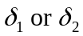 to be sure that it works with the corresponding -value.

Then pick a (perhaps fairly exotic) limit of you own to investigate numerically in this manner. Continue until you feel certain that — given any , you can find a value that works for this .

Using a Graphing Calculator
Starting with 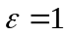, we use the TI-83 catalogue solve function to solve each of the equations
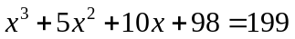 and 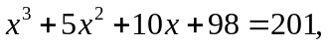
that is,
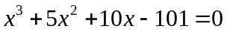 and 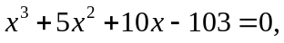

for its solution near x = 3.

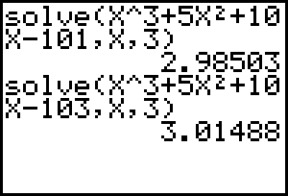

Thus we get 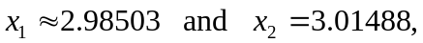 so 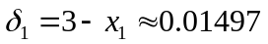 and 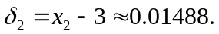 Thus we see that the value 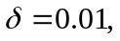 being less than either 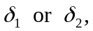 works for .

Using Maple

Starting with , we use Maple's fsolve function to solve the equations

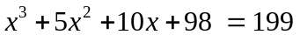 and 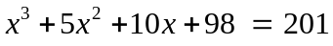

for their solutions to the left of and to the right of a = 3.

f := x^3 + 5*x^2 + 10*x +98:

fsolve( f = 199, x, x=2..3 );

2.985027836

fsolve( f = 201, x, x=3..4 );

3.014879064
Thus we get so and Thus we see that the value being less than either works for .

Using Mathematica

Starting with , we use Mathematica's FindRoot function to solve the equations

and

for their solutions near a = 3.

f = x^3 + 5 x^2 + 10 x +98;

FindRoot[ f == 199, {x,3} ]

{x -> 2.98503}

FindRoot[ f == 201, {x,3} ]

{x -> 3.01488}

Thus we get so and Thus we see that the value being less than either works for .

Using MATLAB

Starting with , we use MATLAB's fsolve function to solve each of the equations

and
that is,
and

for its solution near x = 3.

fsolve('x^3+5*x^2+10*x-101',3)
ans =
2.9850

fsolve('x^3+5*x^2+10*x-103',3)
ans =
3.0149

Thus we get 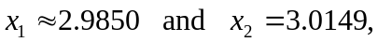 so 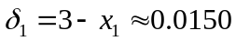 and 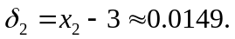 Thus we see that the value being less than either works for .

